Computer Shop System

Business Use-Case Specification: Manage Staff

Version 1.0

Revision History

|  |  |  |  |
| --- | --- | --- | --- |
| **Date** | **Version** | **Description** | **Author** |
| 22/12/2019 | 1.0 | details | Hoang Trung Hieu |
|  |  |  |  |
|  |  |  |  |
|  |  |  |  |

Table of Contents

1. Introduction 4

1.1 Purpose 4

1.2 Scope 4

1.3 Definitions, Acronyms, and Abbreviations 4

1.4 References 4

1.5 Overview 4

2. Business Use-Case Name 4

2.1 Brief Description 4

3. Goals 4

4. Performance Goals 4

4.1 <name of performance goal> 5

5. Workflow 5

5.1 Basic Workflow 5

5.1.1 <name of workflow step> 5

5.2 Alternative Workflows: Still achieve success but in different way 5

5.2.1 <name of workflow step> 5

6. Risk 5

7. Possibilities 5

8. Process Owner 5

9. Special Requirements 5

9.1 <Name of Special Requirement 1> 5

9.2 <Name of Special Requirement 2> 5

10. Extension Points 6

10.1 <Name of Extension Point> 6

Business Use-Case Specification: Manage Staff

# Introduction

## Purpose

The purpose of this business use-case is to show how computer shop manager manage all of staffs’ in Computer Shop

## Scope

The scope of this business use-case is associated with the computer shop to be deployed

## Definitions, Acronyms, and Abbreviations

None

## References

None

## Overview

The rest of the Business Use-case Specification contains goal, risk, process owner and special requirement.

# Business Use-Case Name

## Brief Description

The use case decribes how Computer shop’s manager manages staffs’, trainee’s and applicant’s profile in Computer Shop

# Goals

The goal of the business use-case is helpl to manage all of profile in Computer Shop

# Performance Goals

## <Create staffs’ profile >

When staffs or trainees send their profile or cv, Computer shop manager will summarize and create a new record that depends on these profile.

**4.2. <Edit staffs’ profile>**

When staff have some change about their address, phonenumber or something, Computer shop manager will go to the system and edit these staffs’ profile.

**4.3. <Delete staffs’ profile>**

If anyone doesn’t work in computer shop, their profile or record need remove to save area of management profile databse.

# Workflow

When staffs in computer shop send their profile for manager, they will summarizes or generalise their profile and related document. After that, they will create and write a new profile that depends on available profile. When having profile, manager need to wait for staffs’ validation that all information is correct or not. If information is correct, they will save it in management profile room. If information is not correct, manager will update information is wrong. And it can be removed from database when he or she do not work in shop anymore.

## Basic Workflow

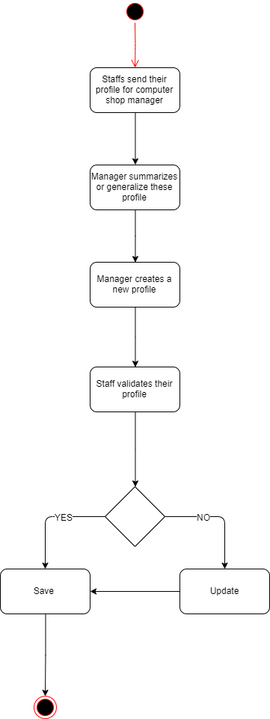

# Risk

No special.

# Possibilities

No special.

# Process Owner

The process owner if this usecase is the administrator or can be called manager of the computer shop who deal with the situation.

# Special Requirements

No special.

# Extension Points

## <No extension Point>